MT team 2009 fieldwork report
Nick Johnson

Predictably Graham is working around the clock on the new SPAM4 MT data acquisition systems up until the minute before they are packed into 10 crates to be shipped to Addis. Consequently the equipment, collectively weighing about half a ton, leaves Edinburgh on the same day as me so when I arrive my first few days are spent exploring Addis, waiting for the go-ahead from customs to begin the notoriously bureaucratic import procedure.
It takes about three days of waiting for emails containing vital documents, paying numerous ‘fees’ for exactly what I still have no idea, trying to explain via an interpreter what our equipment does (to simply say it is a conductivity meter does not cut it!) and drinking macchiatos at the very dull customs department of Bole Airport while we wait for what seems like eternity, before our ten shiny boxes finally appear. Given the general level of chaos it seems like a miracle that the boxes have been found among the mountains of other stuff in the vast hanger-type warehouse.

It is now Wednesday, we have our gear, Graham has arrived (and immediately started working on SPAM 4 software in his hotel room), Sophie is due to arrive tomorrow night – 2 days late due to adverse weather conditions in Europe – and we plan to leave for Afar on Friday. This gives Mohammed and me 1 day to arrange all other supplies needed to support 6 or so scientists, three drivers, 1 cook, 1 camp manager and many what turn out to be temperamental site guards for about a month in the field. We have our work cut out, but none the less we shopped from dawn ’till dusk and got everything apart from ‘edible oil’ and water which apparently we can get on the way. Once finished, Mohammed takes me to a local, dimly lit bar for a well deserved draft beer. Unfortunately it is not dark enough to hide my ‘faranghi’ appearance so the place falls silent and all eyes gaze on me – refreshing beer all the same.
Late in the day we had a call from Lorraine, panic stricken over vehicle arrangements. It turns out that we only have two vehicles booked not the three we require, however Dereje (the vehicle hire company manager) manages to rouse another driver from somewhere who is prepared to leave at 6.00 am in the morning. As it happens our planned departure time is a joke anyway (I am beginning to realise that all western ideas about times and appointments should be forgotten in Ethiopia), and we finally get away at 10ish.
After a few hours driving it’s getting hot and the scenery is spectacular as we descend into the rift valley – surely it can’t get any hotter? Wrong. We finally arrive at the geo-thermal camp in Semara at about 8 pm – not too bad when all things are considered. The camp, to be our home for the next 3 weeks, belongs to the Geological Survey of Ethiopia – it is basic and has a disused feel about it with some huge abandoned drilling rigs and other bits of equipment scattered about the place. But at least my tin box - one of 4 in a converted shipping container many of which make up the camp - has air conditioning.

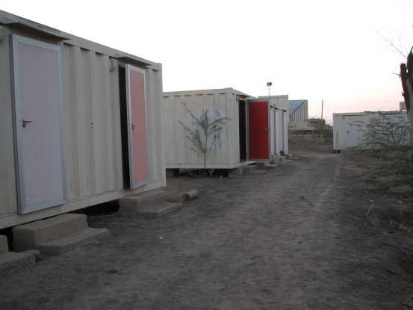
Camp

We soon find out that the resident camp cook is in prison for fighting (or was it cooking the books?) so within the hour we arrange for Mirron (our excellent cook from last year) to travel from Addis the next day with the GPS team – Danny our camp manager also from Addis is now smiling even more than usual (we all just hope that the other cook remains in prison for the duration!)

In the morning we decide to go for breakfast and a quick coffee at the new (and only) bar in Semara which just happens to be a stones throw away from camp - 2 hours and a coffee ceremony later we emerge ready for action…the plan is that Graham will continue working on the beloved SPAM4 in the confines of the camp whist Sophie, Mohammed and I go to scout out some possible MT sites.

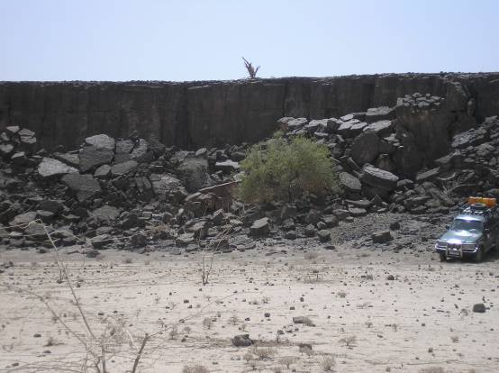
Giant lava flow. Site 907.

The profile along which we hope to collect MT data at around 15 sites, is approximately 10–15 km north of the main road through Semara and roughly parallel to it. It traverses the Hararo segment of the rift (which is less active compared to Dabbahu) and with a site spacing of ~3 km its length will be ~50 km. Access to the sites prior to arrival in the field is a complete unknown but judging by the SPOT satellite image that we have it looks tricky to say the least. None the less we load the coordinates of several potential sites into the GPS, leave the tarmac behind at a suitable looking spot and start following the small arrow on the GPS screen, directing the drivers of the Toyota Landcruisers by means of vague arm waving – they soon get the hang of what was to become their favourite phrase in English ‘…good Sophie?’. To our delight and amazement we are soon at ‘test-site 1’ then 2 and so on – ‘this is too easy’ we thought…but it did in fact set a precedent for the remarkable ease with which the rest of the field work would go.
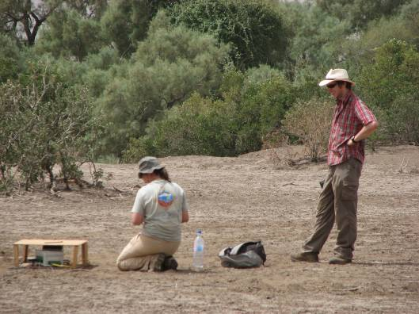
I watch Sophie work (SPAM3)

The following day we all leave camp early for ‘test site 1’ with SPAM3 and SPAM4 on board and the idea of recording with both sets of equipment at the same site for comparisons sake. And on the whole it is a successful day with data acquired from both systems which look comparable. That said some problems with circuitry caused by extreme temperatures (of nearly 50ºC) emerged which would remain with us, keeping Graham and later Alf entertained for quite some time.
Setting up an MT Site
Once we have navigated to the approximate location for an MT site we now decide exactly where to deploy, but we soon learn that before doing this we must first let the guards decide where they would like to camp. Otherwise they will stubbornly refuse to move to a sufficient distance such that our sensitive instruments will not know they are there.
After having set up one or two sites each person in the team soon adopts a set of jobs to do and gets on with them;
Sophie and one driver bury four electrodes in the ground forming a precise N-S/E-W cross with arms of ~100 m - these measure the fluctuations in the electric field. In order to get good contact with the ground a thick Bentonite mud (affectionately known as chocolate mousse – we wish!) is mixed up in a hole approximately a foot deep then the electrode is buried in it.
Mohammed, myself and the other driver measure the distance between the electrodes and then align, level and bury two (N-S/E-W) induction coils in the ground – these measure fluctuations in the magnetic field. They are about 1.5 m long by 15 cm round and they are incredibly sensitive – even the wind blowing on them can be detected in the time-series, hence they are buried.
Graham plugs in cables and deals with the computer end of things, running tests and checking that everything is working.
The policeman sleeps.
Now we all stand around the laptop screen - hot, dusty and glad of the rest – tentatively waiting for the first data to be processed either automatically (SPAM3) or by Sophie (SPAM4). If something is not right the usual culprit is a loose connection or dodgy cable which is quickly rectified, then we treat ourselves to some mango juice and head back to camp.

Today saw the start of our up and down relations with the local guards who are hired to look after the equipment (as a continuous 2 day recording is required at each site). Initially, I wrongly presume that these hardy looking locals with their Kalashnikov rifles would be more than capable of looking after themselves in the dessert for two days, but it transpired that they got rather upset if, for example, we did not deliver their breakfast of fresh injera (and yes they mean fresh and good luck to anyone who tries to substitute bread for this) and tea before about 9am. However, once we got the hang of how to keep them sweet they turned out to be very helpful if quirky natured people.
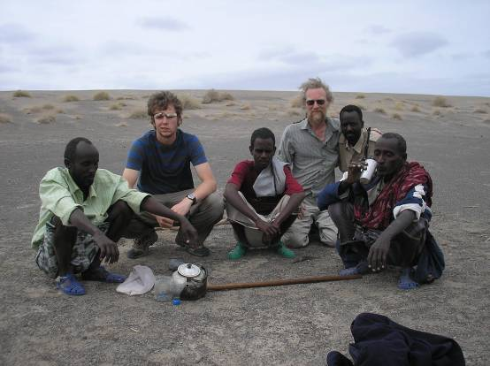
Myself, Graham and some guards

Along with the guards we also hired a sleeping policeman, who we at first presumed must have a sleeping disorder but it later transpired, according to Mohammed, that he actually just had a new girlfriend!
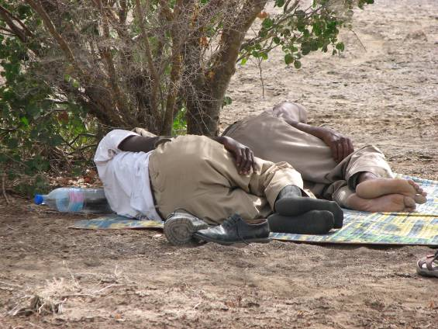
Tired policeman

With Mirron now fully engaged as camp cook the days run by smoothly. Breakfast, usually consisting of pancakes or scrambled egg with chillies and lots of very sweet coffee, is at 6am and we leave for the field at 7. Because we now have two operational MT systems we have two sites running at any one time. Equipment is deployed for two days per site so a typical day involves moving one site and just checking up on/feeding the guards at the other in a leap-frog sort of fashion. At the end of the day a new cross is put on the SPOT image and the profile slowly emerges in a very satisfying manner.
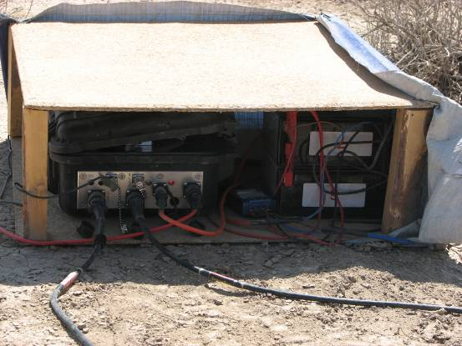
SPAM4!

After a week or so we are joined by Kathy and Alf, who set about collecting TEM data at each of the sites. This is an active source electromagnetic method, the data from which are used to carry out a correction on the MT data. Its acquisition is relatively fast so they soon ‘overtake’ us and leave a trail of blue rocks marking the remaining sites (expertly painted by David, one of our drivers). By midway through the survey the data are looking interesting – definitely some structure at depth seen in the MT and higher electrical resistivities across the rift axis than at the flanks – quite the opposite of what was seen on the active Dabbahu segment…

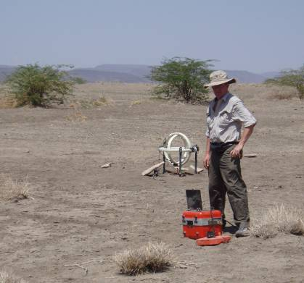
Alf with TEM equipment – receiver coil in background
TEM data acquisition
TEM data are efficiently collected at each of the MT sites by Kathy and Alf. The complete process takes 1-2 hours and involves laying out a 100x100 m square loop of insulated wire on the ground through which a current is passed. Turning the current on and off causes secondary currents to be induced in the ground, the signal from which is recorded by a receiver coil at the centre of the loop.

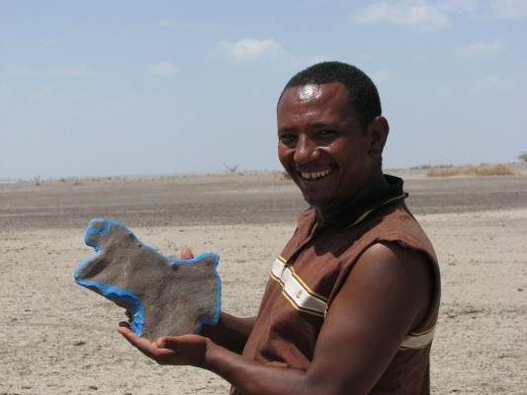
David proudly presents his artwork (giraffe?).

In the evenings the bar provides much entertainment with its bright lights, cheap (30 pence) beer, interesting mix of Amharic and American music, and usually we were not the only ARC team in town making for lively chat and conjecture about what may or may not be going on further north.

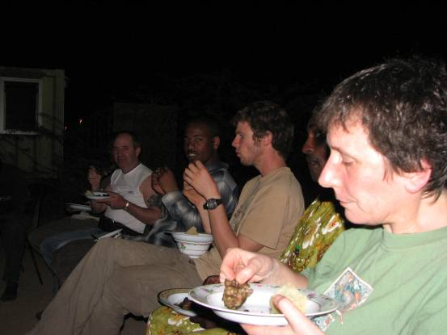
Kathy, Mohammed, me, Bruck and Alf eating goat

Slowly things draw to a close and it looks like we will be finished early. First Sophie heads back to Addis, quickly followed by Kathy and Alf, leaving the last few sites for Graham, Mohammed and myself to deal with. This is slightly daunting for Mohammed and me as we now have to take over in-field data processing responsibilities from Sophie which is not as bad as we think (this is a relief for me as I know that there are months of this to come!). As we arrive at the final site to collect the MT equipment one last time, Ambasso – one of our guards – is clearly very excited about something. At previous sites he has reported lions and tigers in the night leading us to question his eyesight (and ability to use his machine gun safely), but this time he is reporting earthquakes between 9 and 10 o’clock the previous night – interesting. This is later confirmed by Cindy from the seismic team and we look forward to inspecting our data to look for the movement for ourselves. This is not the only evidence we have seen of activity on the Hararo rift segment – at one of the sites to the west of the rift axis what appeared to be fresh cracks were seen in the ground – maybe 5 cm wide and several meters in length.

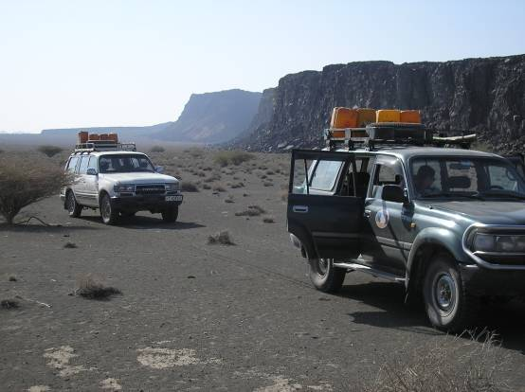
Impressive escarpment east of the rift axis

Before we know it the remaining team members are on the road back to Addis just short of three weeks since we left. I have dished out almost all of what seemed like a ridiculous wad of 100 birr notes to cooks, guards, policemen and anyone else who had helped out.

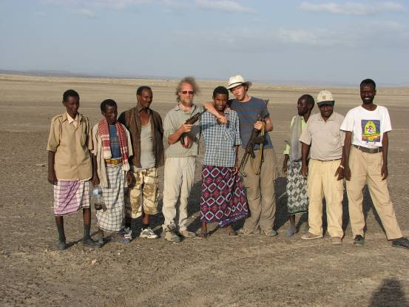
Guards, policeman, drivers, scientists and Danny

To my relief it seems like exporting is easier than importing and after having arrived back in Addis on Wednesday evening, by Thursday evening we are sipping beers on the Ras Amba hotel roof-top terrace having cleared customs and done some manic souvenir shopping. I have changed my flight to 6 am the following morning. All in all it has been a highly successful field season and we have collected a second set of data which look like they are going to make a very interesting comparison to the first.

